6th January 2023

Friendship link celebrated through tree planting

Children in Warwick District and in the city of Bo in Sierra Leone have been planting trees as part of a joint project to celebrate 40 years of friendship between the two communities.

Children in a number of local primary schools including Brookhurst (Leamington), All Saints’ Juniors (Warwick), St Margaret’s and St Joseph’s (Whitnash) have planted trees as part of a joint Climate Action project with their partner schools in Bo, Sierra Leone. Their link partnership is part of One World Link (OWL) – the community, friendship organisation which has linked Warwick District and the city of Bo in Sierra Leone for 40 years.

One World Link was delighted when Leamington Town Council agreed to sponsor tree planting in Bo as its way of marking 40 years of friendship between the two areas. Since then, over 200 trees have been planted in total – some at each of the link schools and some on community land owned by OWL in Bo.

The children’s’ project work focused on the importance of trees for a sustainable future. Pupils were inspired by the work of Wangari Maarthi, Kenyan environmentalist and activist, reading a book about her life - Trees of Peace. They also learnt about the Mayor of the capital Freetown whose ambition is to plant 1,000,000 trees over two years reversing some of the damage caused by deforestation and landslides – Mayor Yvonne Aki-Sawyerr’s aim is to turn Freetown into a Treetown!

Liz Garrett, OWL schools’ coordinator and teacher said, “Children are passionate about protecting wildlife and nature and have been so enthusiastic about tree planting. One boy even donated the sycamore sapling he’d grown from seed during lockdown – it’s now growing on our field! One World Link has always had strong support from Leamington Town Council, and we are both delighted and very grateful that it has chosen to support this project as part of its way of marking our 40 years of friendship with Bo.”

The Mayor of Royal Leamington Spa, Cllr Nick Wilkins, said:
“Leamington Town Council were delighted to actively support and sponsor tree planting in Bo in Sierra Leone. We have worked with our colleagues in One World Link planting trees in some of our Leamington primary schools too as part of a joint Climate Action project.

“Engaging with children around the globe could not come at a more critical time with climate change on the rise. We are proud of our links with Bo, and our planting projects is just one, that has bound us in friendship for 40 years.”

ENDS

Photo Captions
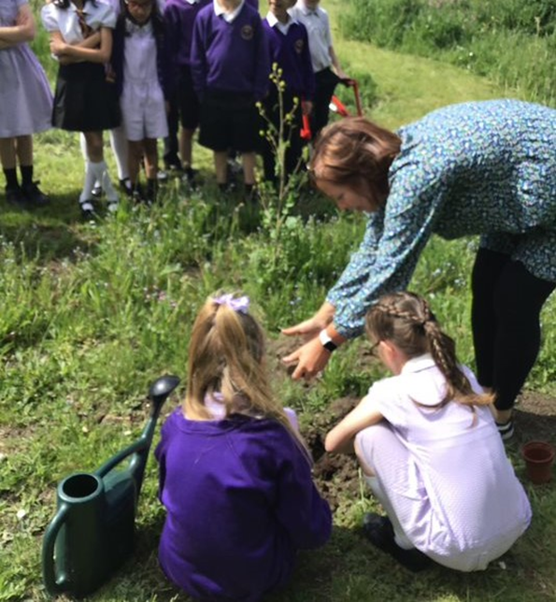
Children planting trees at St Margaret’s Primary, Whitnash, Leamington Spa.
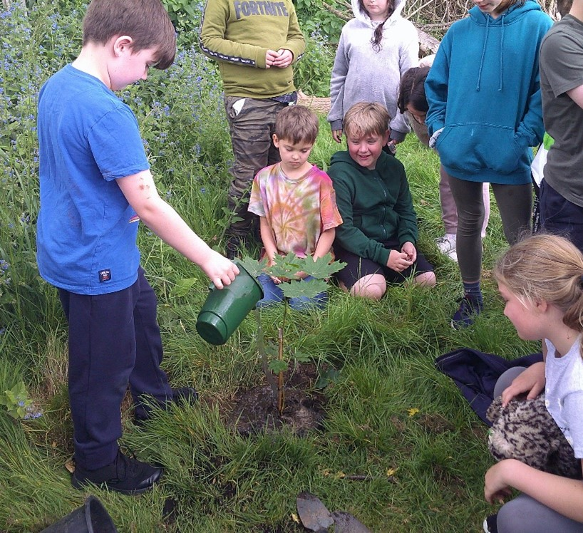
Ewan with Year 4 friends planting his sycamore sapling at All Saints’ Juniors, Warwick

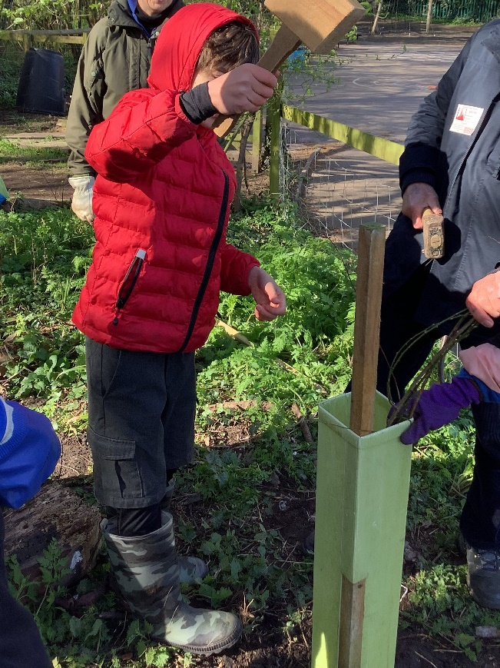
A Brookhurst pupil planting a tree in their spinney.

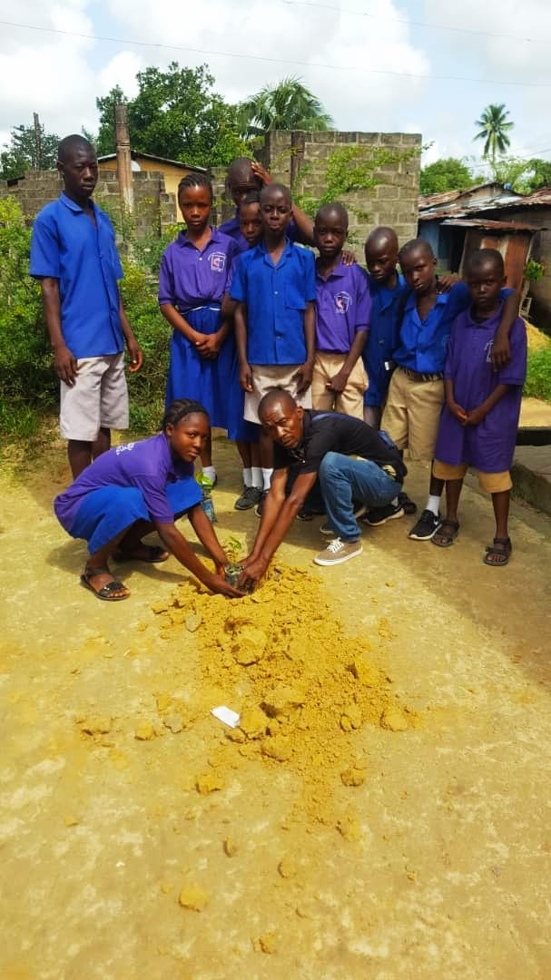

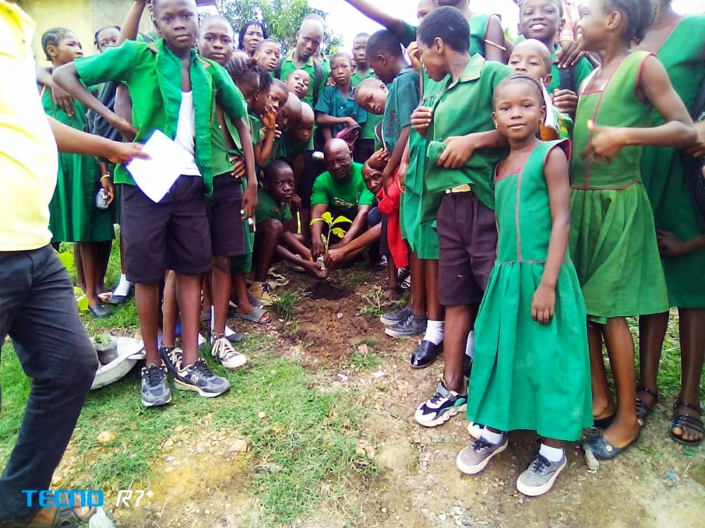

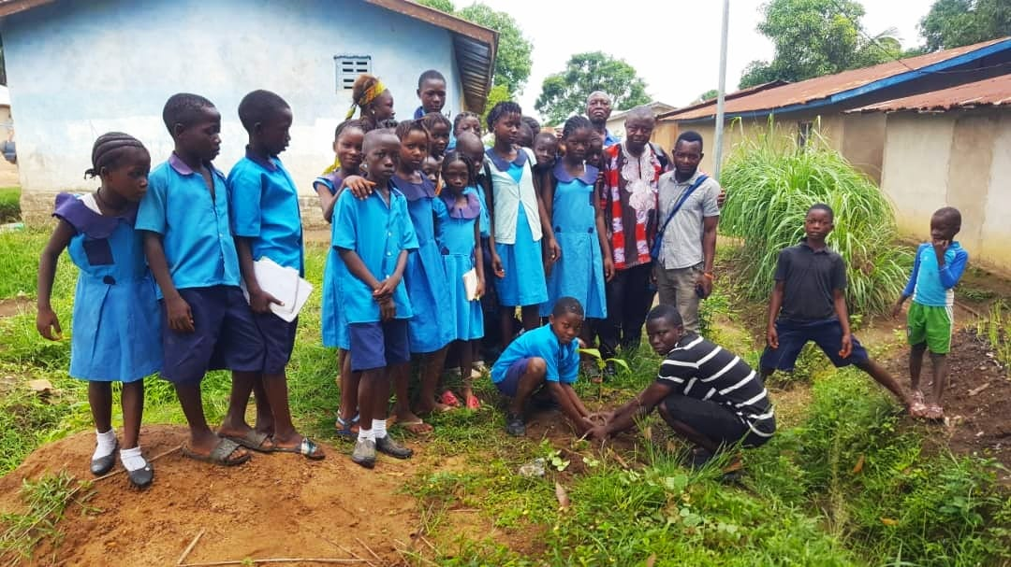

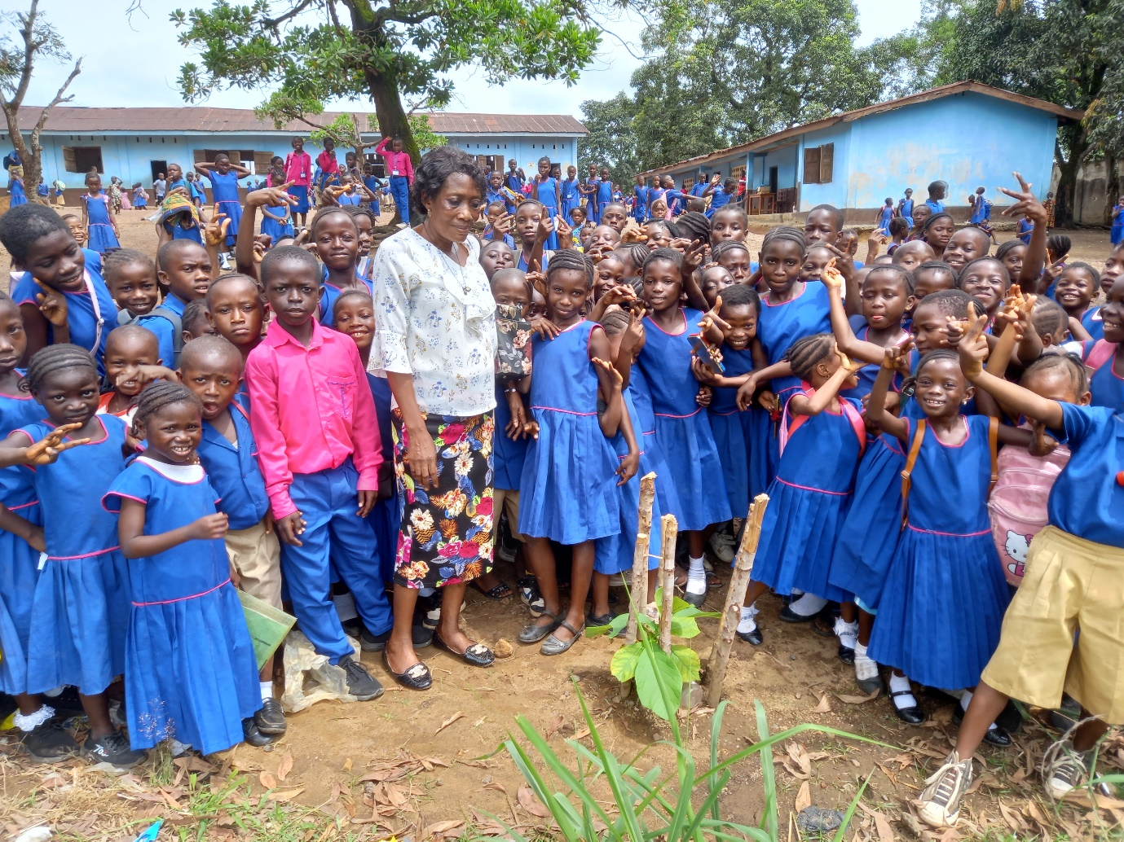

Tree planting underway in schools in Bo, Sierra Leone

NOTES FOR EDITORS

Local charity ONE WORLD LINK has been promoting friendship & mutual learning between Bo District (Sierra Leone) and Warwick District for over 40 years. The link is volunteer run and inspired by a desire for justice, equality and mutual understanding and is maintained through activities such as exchange visits, cultural events, links between schools, teacher exchanges, projects such as the DFID funded Waste Management Project and many other activities. Over the years it has helped to strengthen both communities and their awareness of global & development issues. To find out more about One World Link visit www.oneworldlink.org.uk

For enquiries, please contact Liz Garrett (One World Link Education Co-ordinator) –

T. 07773 704848
E. lizzie.garrett@ntlworld.com

