Other OPB resources
- Video of Isatou explaining/demonstrating how to turn a plastic bag into a crocheted purse

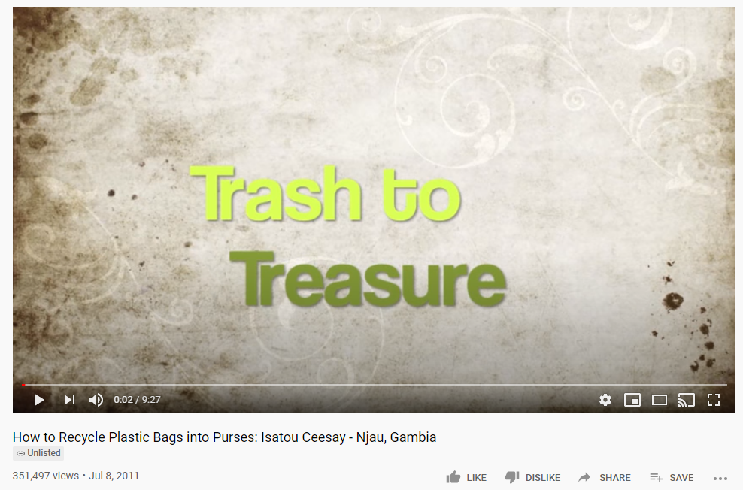
https://www.youtube.com/watch?v=1zZw7yrI22M
10 mins long but you could cut out some of the middle (which is a bit slow)

- Wordsearch using Wolof and English words
http://oneplasticbag.com/wp-content/uploads/2014/10/word_search_gambia_oneplasticbag1.pdf

- Downloadable bookmark
http://oneplasticbag.com/wp-content/uploads/2014/12/BookmarkPlasticBagBook1.pdf

- (related subject- plastic recycling)
BBC news report about Ivory Coast (3.05mins) Positive News! Feb 2020
Ivory Coast schools made from plastic waste - BBC World Service
https://www.youtube.com/watch?v=vaos1rbWgns

