Wangari Maathai 1940 – 2004
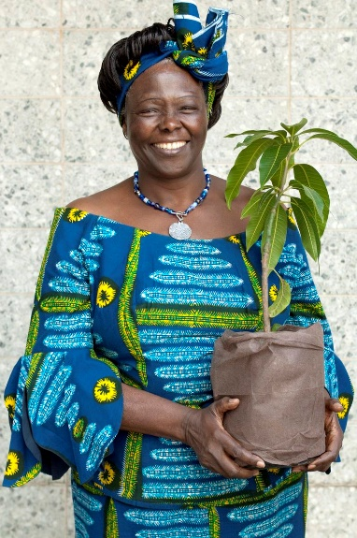

Wangari Muta Maathai was a Kenyan politician and an environmentalist. An environmentalist works to protect the environment. She received the Nobel prize for peace in 2004 for her “holistic approach to sustainable development that embraces democracy, human rights, and women's rights in particular. Maathai was the first black African woman to win a Nobel prize. She is known for her struggle for democracy, human rights, and the conservation of the environment.

Early Life
Wangari Maathai was born on April 1, 1940, in Nyeri, Kenya. She grew up in Kenya and did very well at school. Later, she went on to further education in the United States. She earned degrees in biological sciences. She also studied in Germany. In 1971 she received her doctoral degree at the University of Nairobi. Maathai was the first woman in eastern or central Africa to earn a doctorate. She became a teacher in veterinary science (the care of animals) at the University of Nairobi.
Career
As a passionate environmentalist, she began to promote the planting of trees in 1976. The goal was to prevent deforestation (removal of bushes and trees). In 1977 she founded the Green Belt Movement, a group for planting trees, in Kenya. Since then, more than 40 million trees have been planted across Kenya. Women planted most of these trees.
Maathai and the Green Belt Movement received several international prizes. Their work also spread to several other African countries. In 1986 leaders of the Green Belt Movement established the Pan African Green Belt Network. This movement teaches world leaders more about conservation and the improvement of the environment. The Kenyan government arrested Maathai several times. She was even attacked for being against developments that would harm the environment.
Women working in a tree nursery

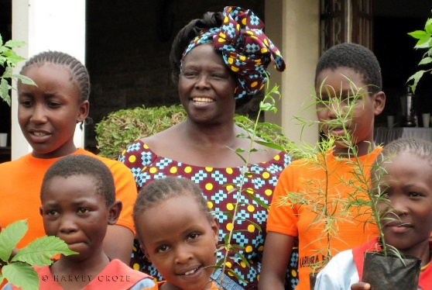
Political Career
In 2002 Maathai was elected as a member of the parliament, which is the main government group in Kenya. In 2003 she became deputy minister of the environment, natural resources, and wildlife. Wangari Maathai died aged 64 on September 25, 2011, in Nairobi, Kenya.

